Task 1: RJ-45 Pin Layout & Colour Codes (T568A vs T568B)

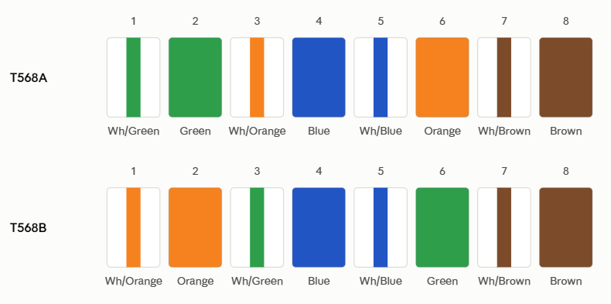
Only pins 1, 2, 3, and 6 differ between the two standards — the orange and green pairs swap positions.

Task 2: Ethernet Standards Comparison

Specification | 10BASE-T | 100BASE-TX (Fast Ethernet) | 1000BASE-T (Gigabit Ethernet)
Speed (Data Rate) | 10 Mbps | 100 Mbps | 1000 Mbps (1 Gbps)
Cable Type | Cat3 (minimum), Cat5/Cat5e | Cat5 (minimum), Cat5e, Cat6 | Cat5e (minimum), Cat6
Wire Pairs Used | 2 pairs (4 wires) | 2 pairs (4 wires) | 4 pairs (all 8 wires)
Max Cable Length | 100 meters (328 ft) | 100 meters (328 ft) | 100 meters (328 ft)
Connector Type | RJ-45 (8P8C) | RJ-45 (8P8C) | RJ-45 (8P8C)

Task 3: Connecting Two Laptops Directly

- I would use a crossover cable. Both laptops are Data Terminal Equipment (DTE) devices. Their Network Interface Cards (NICs) transmit on pins 1 and 2, and receive on pins 3 and 6. A straight-through cable would connect the transmit pins of laptop A directly to the transmit pins of laptop B, causing collisions and preventing communication. A crossover cable crosses pins 1 & 2 to pins 3 & 6 at the opposite end so that Laptop A transmit (Tx) lines map directly into Laptop B receive (Rx) lines.
- Any modern laptop (Gigabit 1000BASE-T or newer), we can use a standard straight-through cable. Modern network cards implement Auto-MDIX (Automatic Medium-Dependent Interface Crossover), which automatically detects pin assignments internally and electronically flips the transmit and receive lines as needed.

Task 4: Real-World Devices and Supported Ethernet Standards

Device | Likely Ethernet Standard | Use
Wi-Fi Router | 1000BASE-T | Connects router to a PC or switch
Desktop Computer | 1000BASE-T | Provides high-speed wired Internet
Network Printer | 100BASE-TX / 1000BASE-T | Connects printer to the college/home network

